Partners 4 Student Safety

  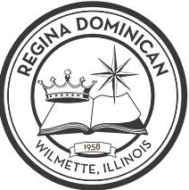

SLOW DOWN!

Crossing Point

Partners 4 Student Safety

  

Students 1st!

Safety 1st!

Partners 4 Student Safety

  

NO CELL ZONE

Put it away!

Partners 4 Student Safety

  

NO STREET DROP OFF!

It’s dangerous!

Partners 4 Student Safety

  

OBEY STREET SIGNS!

Partners 4 Student Safety

  

D39 Parents DO NOT USE REGINA DRIVEWAY!